1)List and explain Visual Basic data types

Different variable types provided by VB are:

1) Numeric

2) String

3) Byte

4) Boolean

5) Date

6) Variant

7) Object

**1) Numeric variables:** VB supports several numeric data types.

They are:

1) Integer and long 2) Single and double 3) Integer and long

Any variables declared as integer (or) long stores whole numbers.

Example: Dim a as integer

Dim b as long

Single and double: variables declared as single (or) double stores fractional numbers. Double

gives the accurate results compared to single.

Example: Dim x as single

Dim y as double

**2) String variables:** String data type stores only text and its value is enclosed with in quotations.

Example: Dim var name as string.

**3) Byte Data type:** This data type holds as integer in the range of a 0-225.

Example: Dim var name as byte

This data type is generally used to store images or sounds etc.

**4) Boolean data type:** This type stores true or false value. It is declared using the word Boolean.

Example: Dim var name as Boolean.

**5) Date variable:** A variable declared as data can store both date and time value.

Example: Dim d1 as date d1=”10-15-2008”

Dim d2 as time d2=”10:30:60 AM”

Two date variables can be subtracted to know the difference between the two dates.

Example: Dim days as integer

Dim d1 as date

Dim d2 as date

D1=”10-15-2008”

D2=”10-10-2008”

Days =d1-d2

In the above example the integer variable days holds the value 5.

**6) Variant variables:** A variable whose data type is not mentioned is said to be as variant

variable. Any variable Declare as variant is handle by VB according to the variables constants. If

you assign a string value, VB treats it as an integer. If you assign a string value, VB treats it as a

string.

To declare a variant variable use ’Dim’ statement without specifying data types as follows.

For example: Dim V1, V2 A Hand Book of Visual Basic 6.0

Page 20 of 82

In the above statement V1, V2 are variant variables since its type is not mentioned. Its

type depends on the contents you can also specify variant type to make the code clear.

Example:

Dim a as variant.

**7) Object variables:** An object variable is a reference to one of many VB’s objects.

Example: A form has two command buttons command1and command2 you can declare two

object variables as

Dim a as command1

Dim b as command2

Each of these two object variable can be set to one of the command buttons present on the

form with the following statements.

Set a = command1

Set b = command2

From now you can manipulate the two command buttons properties present on the

form through the variables ‘A’ and ‘B’.

Example: To change the caption properties of the command button use the statement as follows.

caption =’o.k.’

caption =’cancel’

To change the bold font property of the 2nd command button we write.

b. font bold =”True”.

2)Explain decision making with if..else if..else statement in VB.NET with syntax and Example

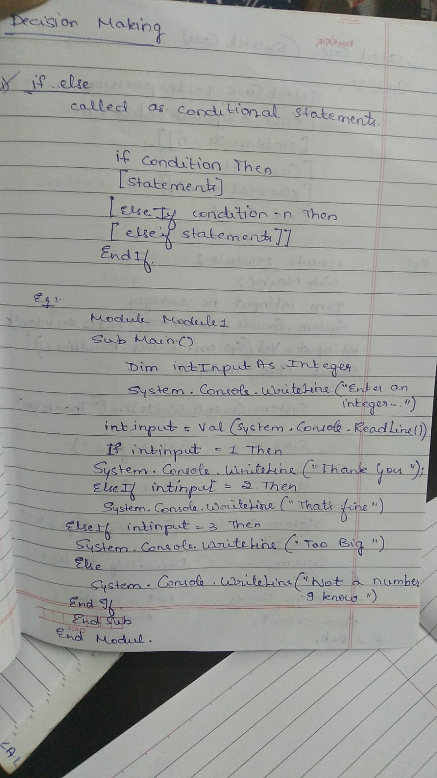

3. Explain Select case structure with syntax and example

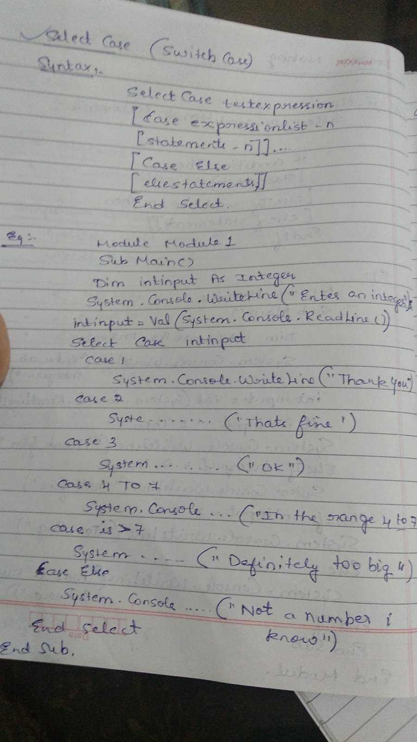

4)Foreach..Next and Do..Until loops with their syntax and example

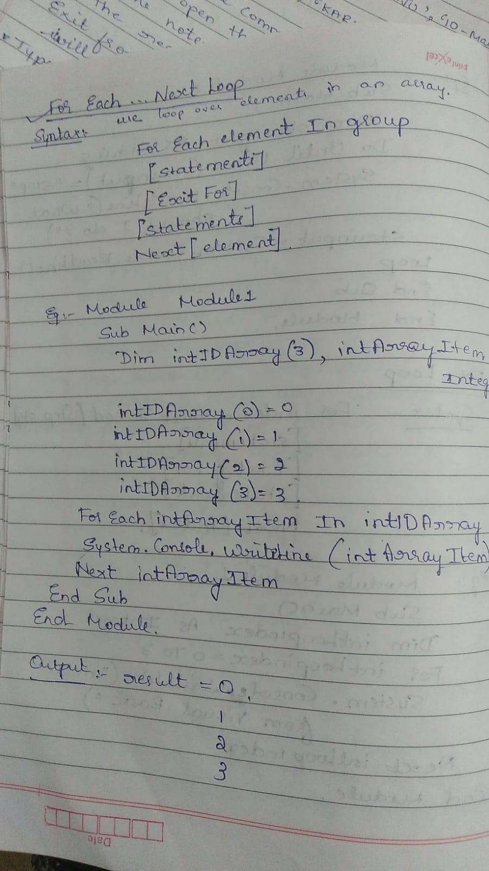

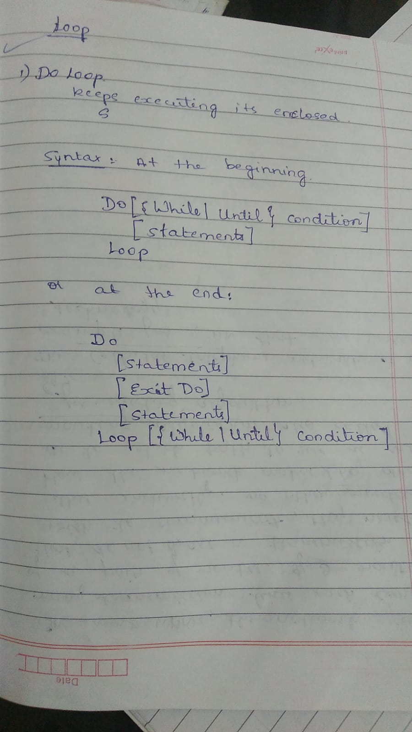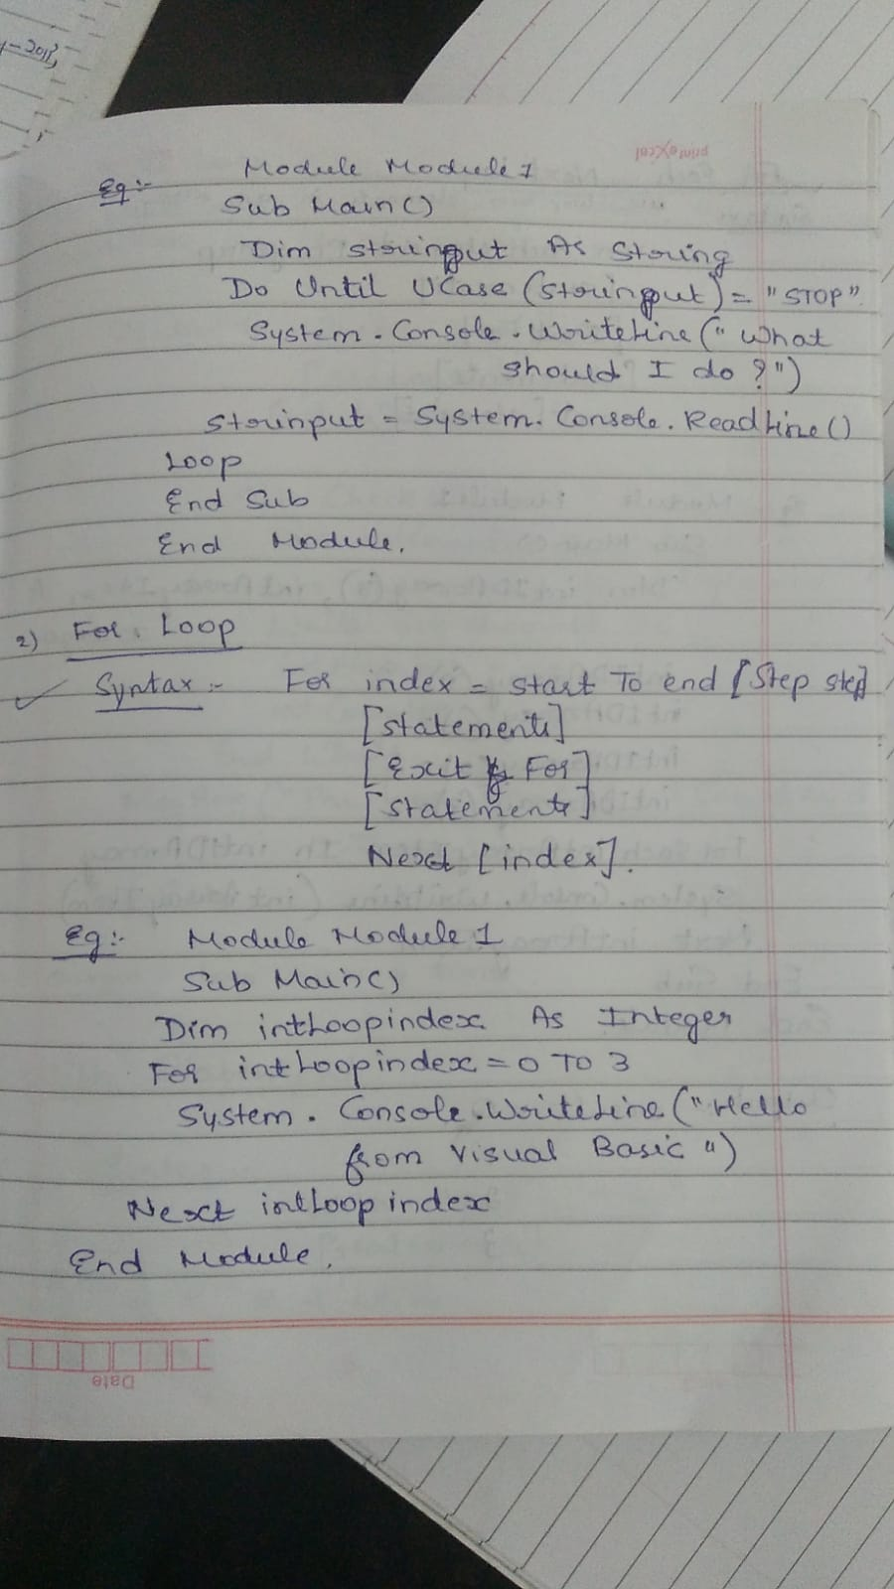

5. Write a note on scope of variables in VB.NET

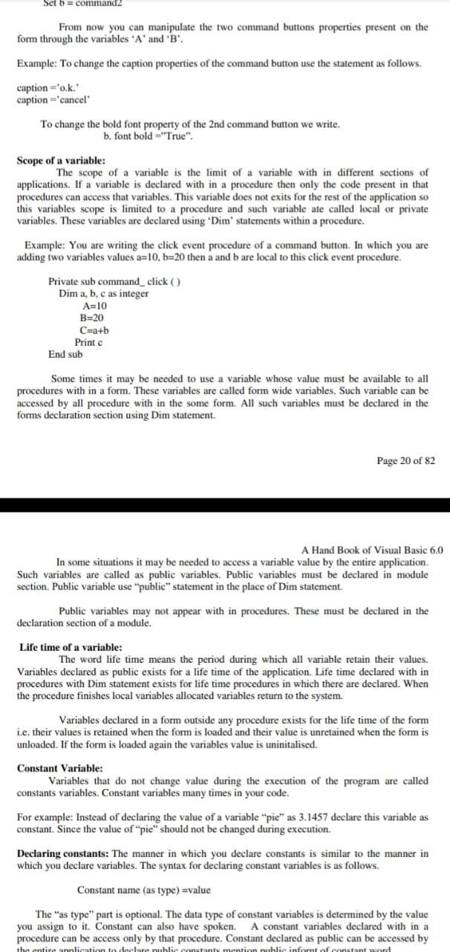

1. Explain For loop with syntax and example



7)Write a note on Standard and Dynamic arrays.

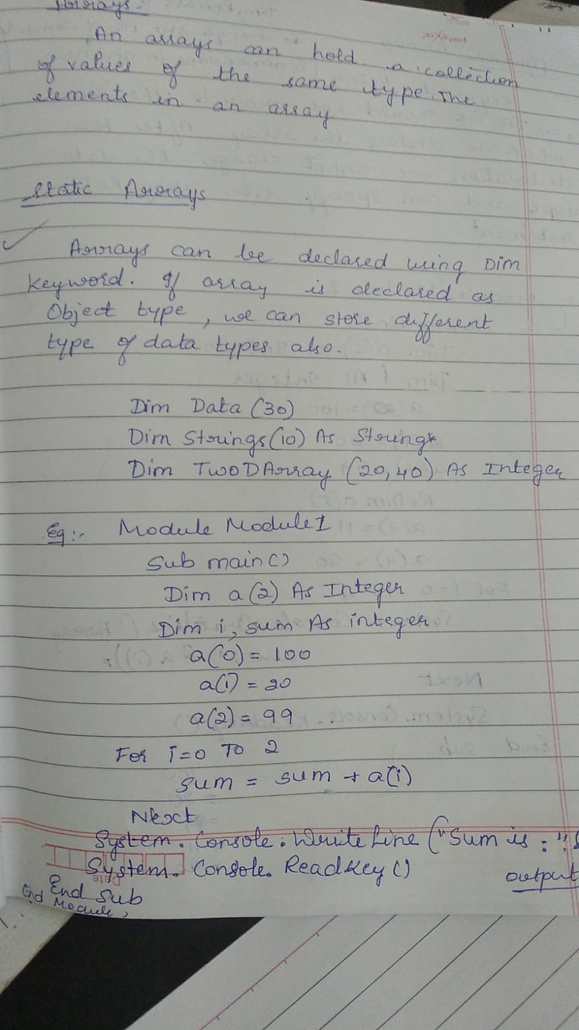

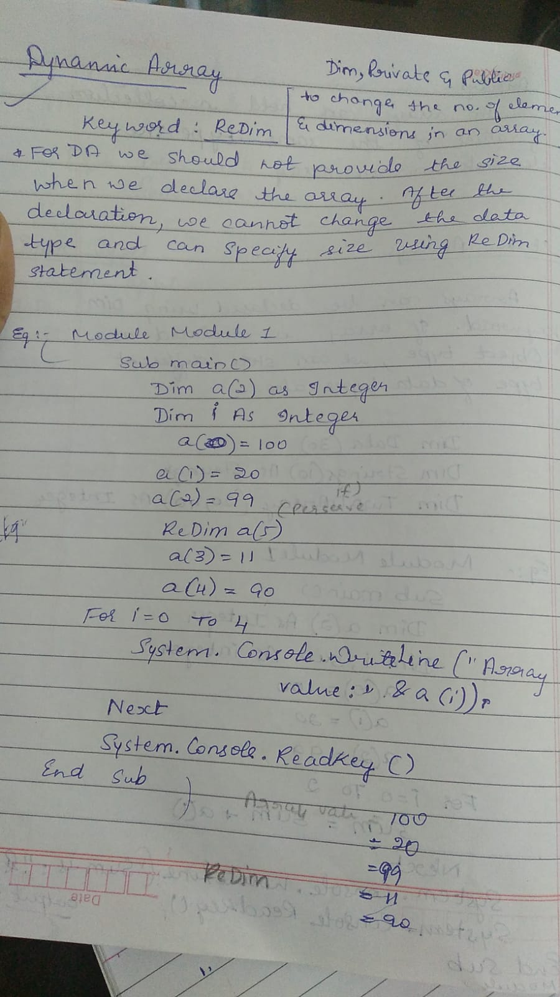

8)Explain the purpose of REDIM and PRESERVE keywords with suitable example



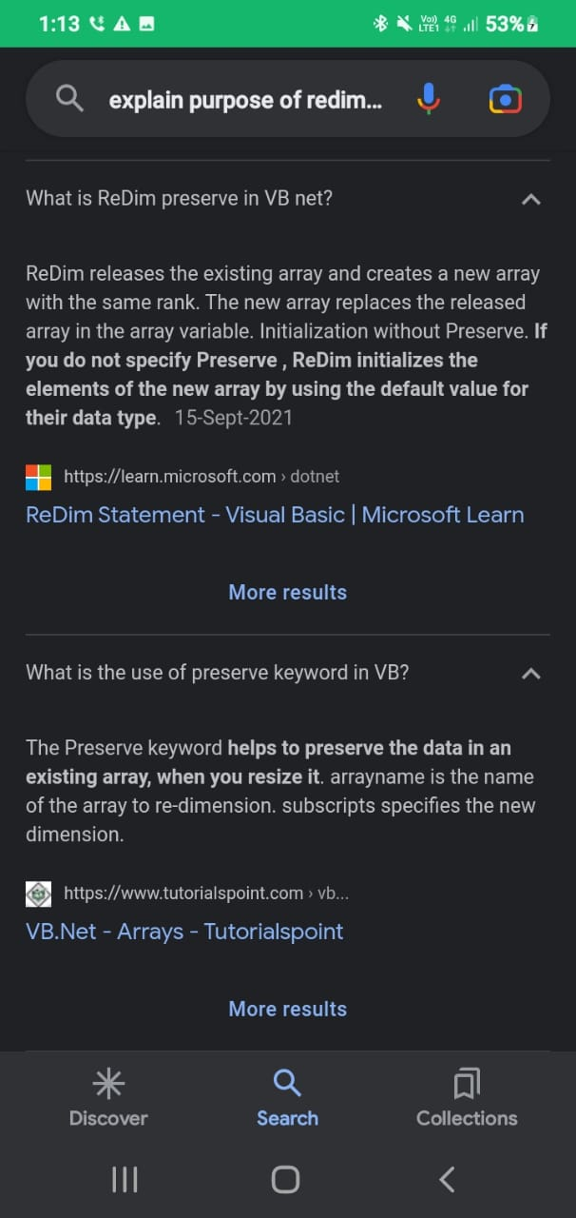

11. Explain any four methods of windows form control

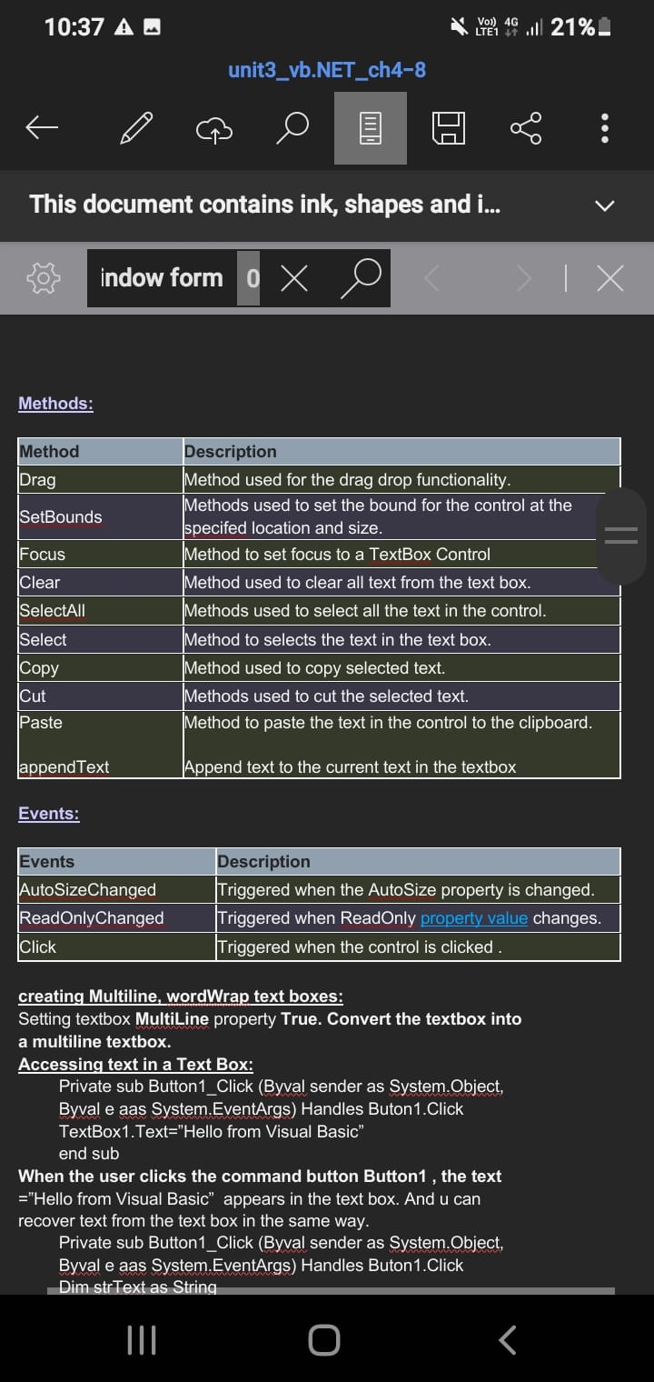

12)Explain any FIVE unique properties of Form

AND

16. Explain the following properties of a textbox

i) Multiline

ii) MaxLength

iii) Wordwrap

iv) Scrollbar

v) PasswordChar

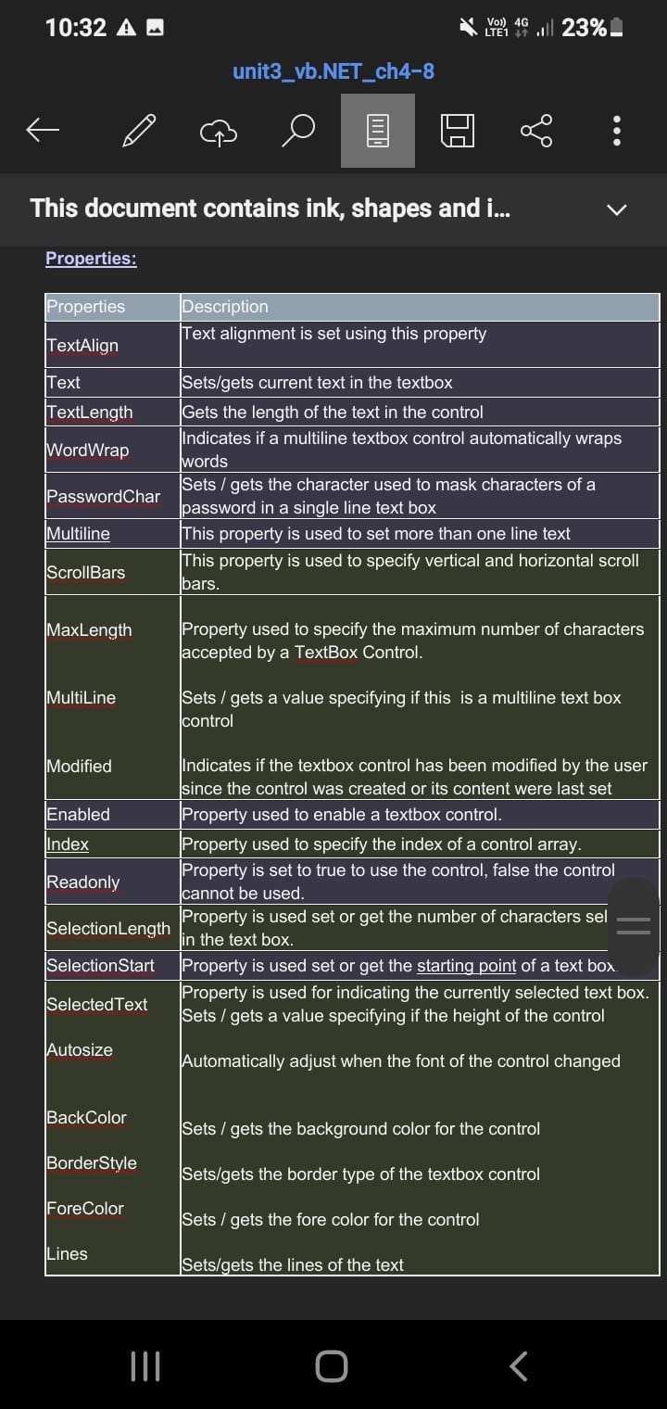

13) Explain MsgBox Function with an example

The objective of MsgBox is to produce a pop-up message box and prompt the user to click on a command button before he /she can continues. This format is as follows:

yourMsg=MsgBox(Prompt, Style Value, Title)

The first argument, Prompt, will display the message in the message box. The Style Value will determine what type of command buttons appear on the message box, The Title argument will display the title of the message board.

<tr" style="box-sizing: inherit;">

#### Example 12.1

Private Sub Button1_Click(ByVal sender As System.Object, ByVal e As System.EventArgs) Handles Button1.Click

Dim testmsg As Integer

testmsg = MsgBox("Click to test", 1, "Test message")

If testmsg = 1 Then

MessageBox.Show("You have clicked the OK button")

Else

MessageBox.Show("You have clicked the Cancel button")

End If

End Sub

14. Explain InputBox Function with an example.

An InputBox( ) function will display a message box where the user can enter a value or a message in the form of text.

myMessage=InputBox(Prompt, Title, default_text, x-position, y-position)

myMessage is a variant data type but typically it is declared as string, which accept the message input by the users. The arguments are explained as follows:

Prompt -  the message displayed normally as a question asked.

Title -  The title of the Input Box.

default-text -  The default text that appears in the input field where users can use it as his intended input or he may change to the message he wish to enter.

x-position and y-position -  the position or tthe coordinates of the input box.

Microsoft.VisualBasic.InputBox(Prompt, Title, default_text, x-position, y-position)

The parameters remain the same.

#### Example 12.3

Private Sub Button1_Click(ByVal sender As System.Object, ByVal e As System.EventArgs) Handles Button1.Click

Dim userMsg As String

userMsg = Microsoft.VisualBasic.InputBox("What is your message?", "Message Entry Form", "Enter your messge here", 500, 700)

If userMsg <> "" Then

MessageBox.Show(userMsg)

Else

MessageBox.Show("No Message")

End If

End Sub

The inputbox will appear as shown in the figure below when you press the command button

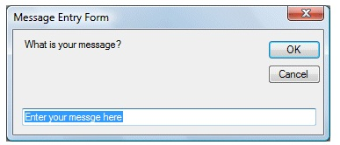

1. Explain Handling Mouse Events

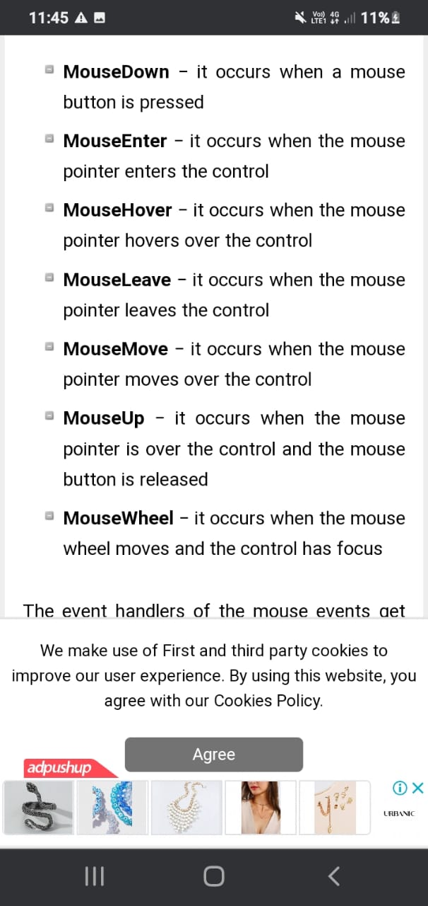

18. Write the code for following with reference to ListBox:

i. Removing items

ii. Adding items

iii. Sorting items

iv. Determining number of many items

v. Determining items selected

i )

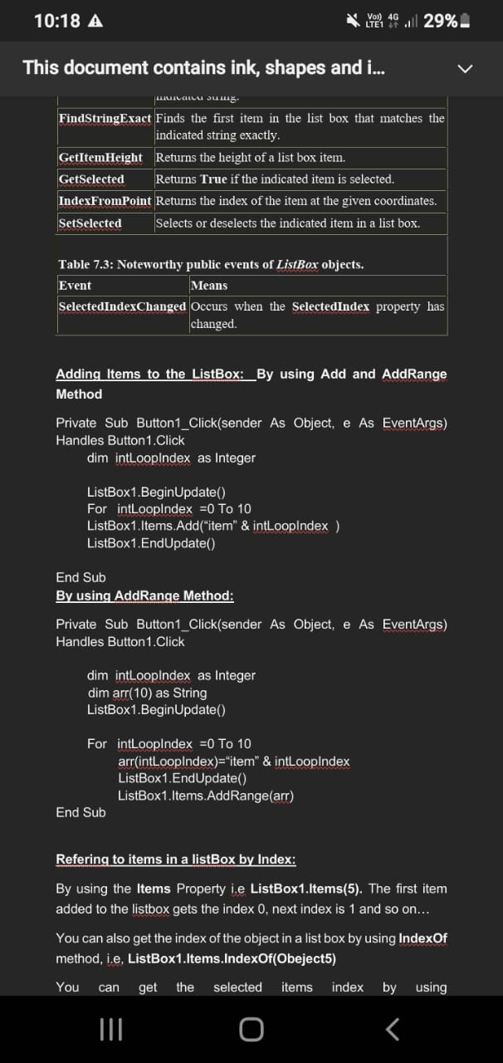

ii )

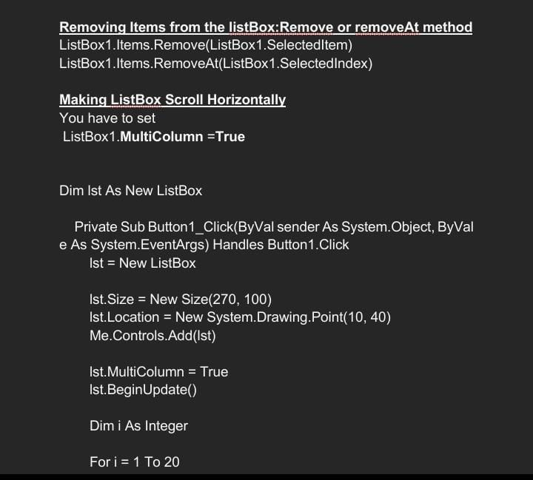

19. Write procedure to set the following for the button’s click event :

i. Button’s caption

ii. Button’s foreground and background color

iii. Button’s font

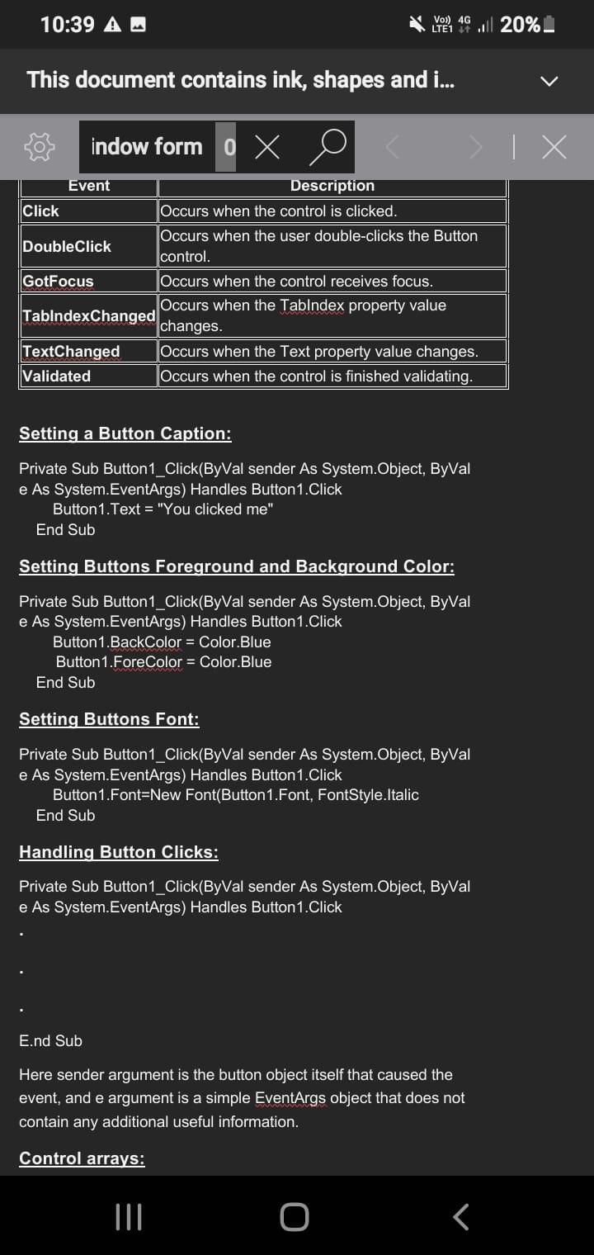

1. What is the use of trackbar? Explain its unique properties.

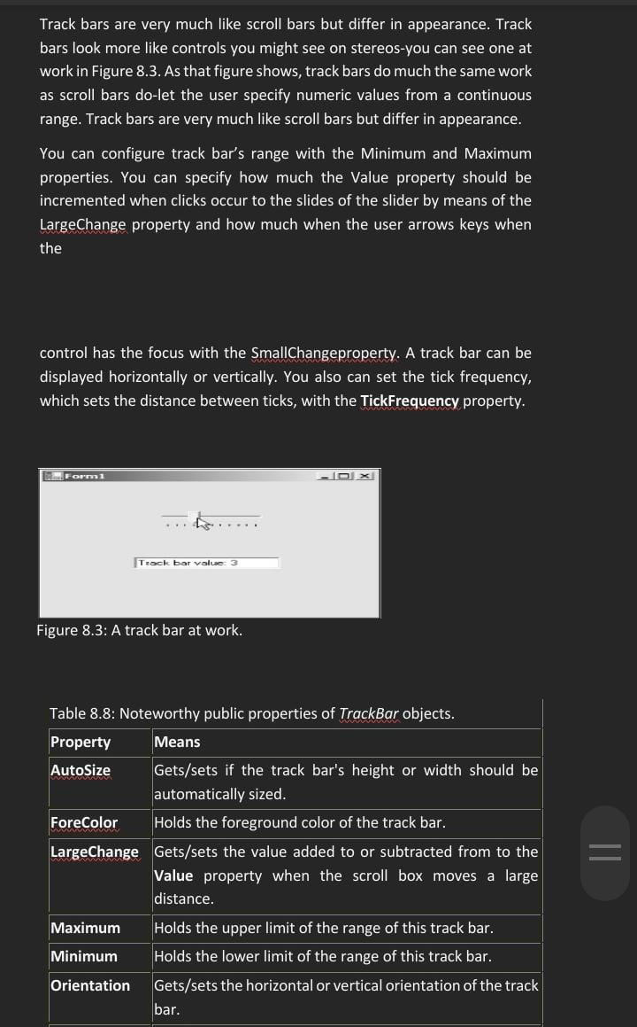

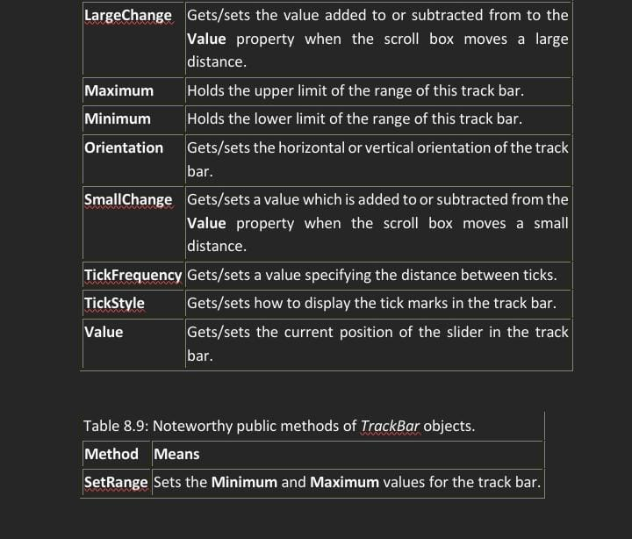

21. What is use of Progress bar control ? Explain its unique properties

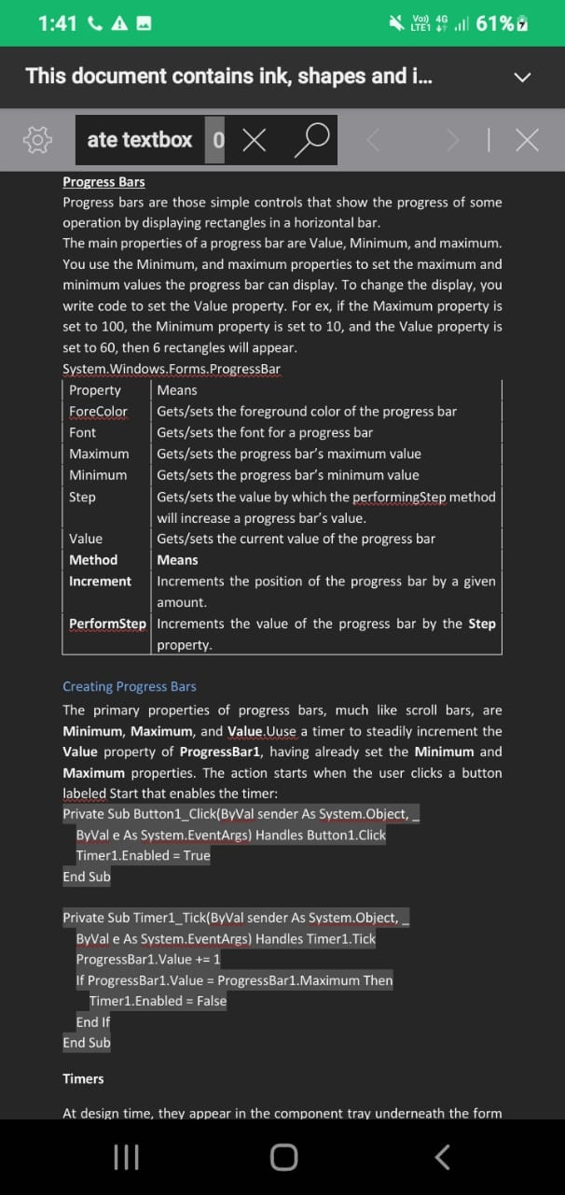

23. Explain the following with reference to PictureBox:

i. Setting or Getting the Image

ii. Adjusting size to contents

iii. Handling events

